GGE289 METRICS REPORT

Contents

1. Project Introduction 2

2. Schedule Variance 2

2.1. Tabular Representation 2

2.2. Causal Analysis(Phase wise) 2

2.3. Corrective Actions(Phase wise) 2

3. Product Defect Density 3

3.1. Corrective Actions 3

3.2. Root Cause Analysis 3

4. Project’s Process Defect Density 3

4.1. Corrective Actions 3

4.2. Root Cause Analysis 3

# Project Introduction

##### **Project: GGE289 Proton Q 1500 12V 25A**

**Objective:** We got feedback from Marketing team that due to long cut in the some area.Now people start using 240ah battery instead of 150 ah regular demand battery for long backup requirement.So Domestic team required 1500 12V proton Q model with 25amp charging current.They also want increased charging profile on low grid input voltage and Grid input voltage range starts from 95V instead of 100V.

**Scope:** To develop the inverter (1500 12V) for domestic market with 25amp charging current.

**Measurement Goals:**

**Schedule variance :- +/- 20%**

**PDD:- 0.10 +/- 0.02**

**PPDD:- 0.20 +/- 0.02**

**Project Manager:** Deepesh Jain

**Team Size :**  10

# Schedule Variance

## Tabular Representation

|  |  |  |  |  |  |
| --- | --- | --- | --- | --- | --- |
| Date | Plan Value | Earned Value | Actual Cost | Schedule Variance  ((EV-PV)/PV)*100 | Cost Variance ((AC-EV)/EV)*100 |
| 17 Sep 2022 | 31 | 25 | 25 | -19.35% | 0% |
| 24 Sep 2022 | 80 | 80 | 68 | 0 | -15% |

## Causal Analysis(Phase wise) (RD Phase and starting of Planning Phase)

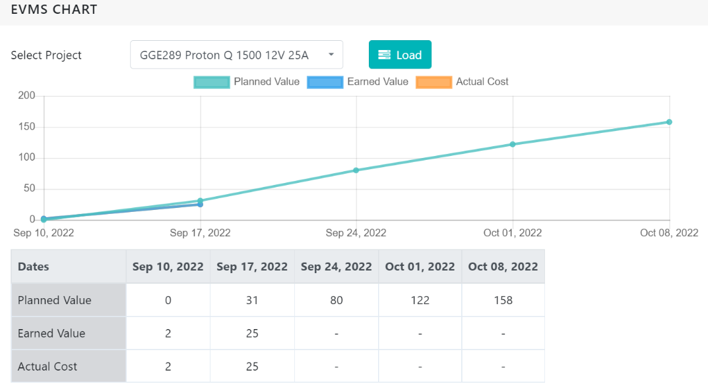

**RD and starting phase of Planning Phase:**  The schedule variance at the end of the first week is -19.35% which is under limit but we are behind from our plan.And when we check the reason of this variance we found that, Project manager was on leave for 1 day.So planned work was not completed on that day.

**(Planning Phase and Design phase)**

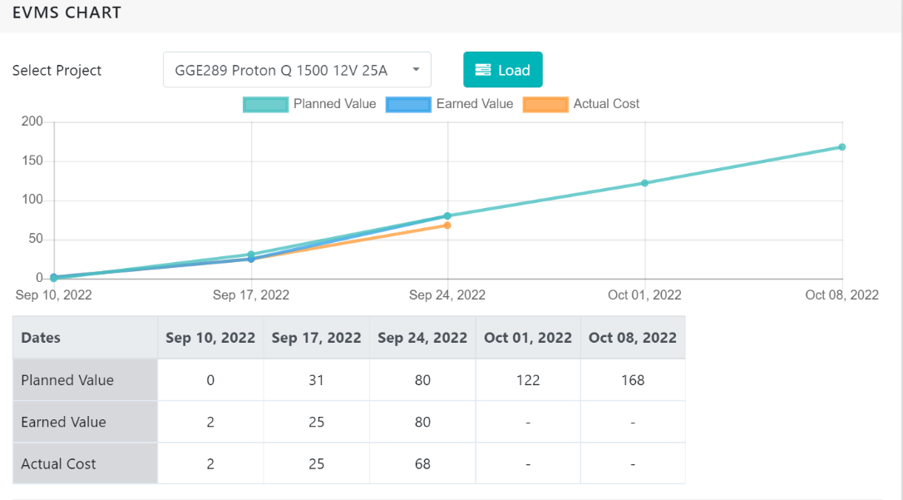

The schedule variance at the end of the second week is 0% which is under limit and we are not behind from our plan.And actual cost coming -15% .

## Corrective Actions(Phase wise)

**RD and starting phase of Planning Phase:**Currently no action required.

**Planning Phase and Design phase:**Currently no action required.

# Product Defect Density

## Corrective Actions

NA

## Root Cause Analysis

NA

# Project’s Process Defect Density

## Corrective Actions

NA

## Root Cause Analysis

NA

**Date :**

[29/09/2022]